WEST LONDON WASTE AUTHORITY
Report of the Finance Director | 21 January 2022
2022/23 Budget

SUMMARY
This report sets out the 2022/23 budget proposal
RECOMMENDATION(S)
The Authority is asked to:-
- Approve the 2022/23 budget
- Approve the payment of £0.2 million per borough for agreed improvements, principally HRRC diversion rates
- Approve the Pay As You Throw (PAYT) rates in section 15 and the PAYT levy made up of two components totalling of £50.4 million
- Approve the Fixed Cost Levy (FCL) of £14.2 million in section 16
- Approve the recommended trade and construction prices in section 17 and delegated authority to the Treasurer to change these in year should the need arise
- Approve the new proposed capital budgets in section 18
- Approve the target level of reserves of £9.2 million to act as a buffer for managing risks and avoiding supplementary levies, in section 19
- Note the Medium and Long Term Financial Plan in section 20
- Introduction

  - The 2022-23 draft budget was considered at the Authority meeting in December and was shared/presented to meetings of the West London Environment Directors and West London Treasurers. Three borough finance teams also took up the offer to meet up and run through the budget and Authority plans. The borough Finance Directors were also asked to provide a formal response to the budget proposals.
  - The report which follows is almost the same as December’s report but updated for:
- Minor changes to the numbers improving the bottom line and very minor changes to text e.g. typos
- Tidying of a column in a table in section 15 together with additional commentary about the tables
- Use of the latest 2021-22 forecast in the table in section 2
- Formal feedback from borough Finance Directors (section 21 and appendix 2)
  - There are no other changes
- Executive Summary
  - In overall terms boroughs will see a reduction in total levies of more than £0.5 million. Furthermore each borough will also receive a payment of £0.2 million for principally HRRC improvements.
  - The main driver for this positive position is that a one off benefit of £2 million is expected next year from our PPP income sharing arrangements.
  - The 2022/23 budget proposes to pass on the £2 million benefit to boroughs through reduced levies and by contributing towards some of boroughs costs which are aligned to the Authority’s strategic objectives.
  - The table below sets out the 2022/23 budget and the movement from the 2021/22 budget. The latest 2021/22 forecast is also included to provide context and illustrate the current level of activity.
 | 2021-22 budget  £ 000’s | 2021-22 forecast £ 000’s | 2022-23 budget  £ 000’s | Changes in budgets £ 000’s
Costs
WTD - Waste Transport and Disposal | 50,363 | 47,109 | 49,558 | (805)
Funding of borough services | 0 | 0 | 1,200 | 1,200
Depreciation | 9,240 | 9,240 | 9,809 | 569
Financing Cost | 5,230 | 5,230 | 5,105 | (125)
Premises | 2,620 | 2,722 | 2,672 | 52
Employees | 2,252 | 2,305 | 2,648 | 396
MRF Service Costs | 2,469 | 2,052 | 2,148 | (321)
Supplies and Services | 968 | 1,034 | 1,198 | 230
Revenue Funding of Debt | 941 | 941 | 962 | 21
Concession Accounting Adjustments | (4,382) | (4,382) | (4,473) | (91)
Total costs | 69,701 | 66,249 | 70,828 | 1,127
Income
Levies | 65,119 | 62,148 | 64,552 | (567)
MRF service income | 2,469 | 2,052 | 2,148 | (321)
Other Income | 2,113 | 2,522 | 2,128 | 15
PPP one off benefit | 0 | 0 | 2,000 | 2,000
Total income | 69,701 | 66,721 | 70,828 | 1,127
Total (surplus)/deficit | 0 | (472) | 0 | 0
  - The budget headings are per our usual format for regular budget monitoring reports. The most notable movements relate to the one off benefit. Note that the MRF activities have a neutral effect with costs being passed through to Ealing for the services provided.
  - Plans for the coming year and an explanation of budget items follows.
- Focus for 2022/23

  - One area of focus is the pass on of the PPP one off benefit to boroughs, in a way that is aligned to the Authorities strategic objectives.

  - So, £200,000 will be paid next year to each borough for improvements in services, principally HRRC operations (an area of strategic focus for the Authority) to drive better diversion rates. The improvements will be agreed between borough Officer’s and the Authority’s Senior Management Team using diversion targets. This also provides a catalyst for boroughs to make continuous long-term savings. The agreed use of funds will be reported to the Authority.

  - The remainder of the one off benefit (i.e. £0.8 million) will directly offset waste disposal spending and therefore reduce the overall costs and consequently the levies which boroughs will have to pay. This is reflected in the overall 0.7% reduction in levies.

  - Elsewhere in the budget, the circular economy hub project is another area of particular focus for 2022/23 with interest from borough colleagues. A scalable and flexible solution using adapted shipping containers has previously been reported. This provides the opportunity to move containers from location to location and provide a range of options to meet the needs of any borough site.

  - The plan for the coming year includes continuing to work with borough colleagues and investing in container based solutions, procuring and refitting them as workshops, shops and community spaces. The aim is to have at least two circular economy hubs up and running by the end of 2022/23, progressing towards the medium term target of having one each constituent borough.
- Waste Transport & Disposal (WTD)

  - The WTD budget accounts for the majority of the entire WLWA budget and makes up 71% of the overall spend. Strategically, this is where most of the significant saving opportunities can be found.

  - The 2022/23 WTD budget is £49.6 million, a reduction of £0.8 million.
  - The residual waste budget is the key driver and represents 85% of the WTD costs (or 61% of all Authority costs – hence the strategic significance). For 2022/23 this is based on boroughs’ forecasts of residual waste which are 2.5% lower than the 2021/22 budget and reflects the current volumes disposed continuing throughout next year.
  - Looking at the complete picture, the 2022/23 budgeted tonnage is made up of the following materials:
Material | 2021/22 Budget Tonnes | 2022/23 Budget Tonnes | Change
Residual | 444,814 | 433,711 | (11,103)
Mixed organic | 857 | 0 | (857)
Green | 54,127 | 53,610 | (517)
Wood | 15,256 | 17,694 | 2,438
Kitchen | 39,747 | 39,300 | (447)
Other | 7,816 | 11,849 | 4,033
Budgeted tonnages | 562,617 | 556,164 | (6,453)
  - The only notable service change relates to Hillingdon moving from a mixed organics collection to separate kitchen and green collections which will result in cost savings that will flow through to Hillingdon though the PAYT levy. No other significant service changes were advised with borough forecasts reflecting current volumes of throughput.
  - To calculate the budgeted spend, RPIX of 3.0% a mid-range forecast has been applied to contractor prices where there is a contractual indexation requirement. Published forecasts including HM Treasury range from 1.9% to 5.2% and the Chancellors recently reported 4% expectation have been used to benchmark.
  - It is worth noting that within the main PPP contract this impact is partly mitigated by the pricing mechanism which dampens the overall effect of inflation – a very effective feature of the contract. This is highlighted in the sensitivity analysis in section 20. Where contracts are due for procurement, procuring managers have used best available market information to estimate rates for the coming year.
- Depreciation

  - The budget for 2022/23 of £9.8 million is £0.6 million higher than in 2021/22. This principally reflects property asset valuations and indexation agreed with auditors for the latest audited accounts.
  - The largest element of depreciation relates to the SERC (Severnside Energy Recovery Centre) and totals £8.4 million. It should be noted that for depreciation calculations, the SERC has to be separated out into its main components and each key component has to be depreciated over its own expected life.
  - Depreciation for the remaining assets have been calculated using the audited accounts and subsequent change in the asset registers (i.e. additions and disposals).
- Financing

  - The financing costs reflect the interest paid on loans. These have reduced from £5.2 million in 2021/22 to £5.1 million for 2022/23 primarily as a result of the payment profile of repayment loans. With repayment loans a fixed sum is paid every year comprising of both interest and principal repayment. The interest element will continue to fall over coming years, conversely the principal repayment will rise.
  - The largest component of financing costs relates to borrowing from boroughs for the construction of the SERC and totals £4.6 million. The loans are at arm’s length and from a borrowing perspective the boroughs are like any other lender with the loan agreements specifying the relationship with the Authority and including a rate of interest of 7.604%.
  - The interest on loans for the purchase of transfer station freeholds makes up the balance of £0.5 million and represents a PWLB loan at 2.24%.
- Premises
  - The budget for 2022/23 of £2.6 million is almost the same as the budget in 2021/22.
  - The largest component of the premises costs are business rates which account for £2.3 million of this budget of which SERC rates make up £1.4 million and transfer stations £0.8 million.
- Employees
  - The 2022/23 budget of £2.6 million is £0.4 million higher than the 2021/22 level. This growth relates to a range of employee costs including an increase in the establishment, wage inflation (2%), National Insurance (1.5%) and learning & development.
  - The 2022/23 establishment is planned to increase to 40.1 full time equivalent (FTE) posts a growth of 1.8 from the previous year. Putting this into context the Authority employed 42 FTE in 2014/15 and over the last few years FTE numbers have been just below 40. The size of the staffing establishment numbers remains small and stable whilst providing the resource to drive forwards business plan objectives and undertake the increasing volume, variety and complexity of work.
  - A breakdown of the establishment by area of activity is provided below:
Activity | 2021/22 | In year changes | Current | 2022/23 | Change from 2021/22
Contracts/Operations | 18.6 | 1.0 | 19.6 | 20.0 | 1.4
Corporate Services | 8.7 | 0.4 | 9.1 | 10.1 | 1.4
Projects | 11.0 | 0.9 | 11.9 | 10.0 | (1.0)
Total | 38.3 | 2.3 | 40.6 | 40.1 | 1.8
- Supplies & Services
  - The 2022/23 budget for Supplies & Services is £1.2 million and is £0.2 million more than the 2021/22 level.
  - A wide variety of spends make up this total, the most notable being sums set aside for a range of projects including circular economy hubs, waste minimisation activities, carbon survey and support. These form the largest part of the supplies and services budget with spending determined by the progress with the projects. Therefore, spending may not all materialise in 2022/23 and there is a potential for out-turn savings.
  - Other notable items include spending for external audit, insurances and borough services (e.g. committee services, treasury etc.).
  - Budgets for some minor costs have been stripped out.
- Revenue Funding of Debt
  - The loan which financed the purchase of the transfer station sites is a typical repayment loan. It is made up of two components – an element for the interest on the loan (see Financing Costs) and an element repaying the loan principal.
  - The Revenue Funding of Debt is the element repaying the sites loan and totals £1.0 million for 2022/23. This is marginally higher (£20,000) than 2021/22 reflecting that within a typical repayment loan, the amount of principal repaid increases over time and amount of interest falls.
  - It is worth providing the following brief recap of the revenue funding of debt which was detailed in Authority papers recommending the site purchase a number of years ago.
  - It is a requirement for public bodies to ultimately fund the cost of assets through levies and taxes. For the Authority this is achieved through a combination of the depreciation charge and revenue funding of debt.
  - Typically the acquisition of assets result in an annual depreciation charge. This annual expenditure is recovered through the levy mechanism and therefore the levies over the life of the asset fund its purchase.
  - However, the acquisition of the sites freehold is essentially a purchase of land. For land, accounting rules do not allow a depreciation charge. This means that in order to fund the purchase through levies a different (but comparable to depreciation) annual charge is made – the revenue funding of debt.
- Concession Accounting Adjustments
  - Essentially under a PPP arrangement a contractor pays for the construction of an asset and then recovers its investment over a long period through its operational charges to the local authority (i.e. its price per tonne).
  - There are very specific and detailed accounting requirements that govern this type of arrangement. This is because the underlying nature of this transaction is that the local authority essentially owns the asset for a period of time and the contractor is essentially a lender financing the construction of the asset.
  - The key feature of the accounting is the calculation of a concession accounting adjustment to separate out the disposal and financing costs, followed by stripping out from expenditure a notional sum for the repayment of any underlying borrowing by the contractor.
  - The concession accounting adjustments over the term of the contract were agreed with the auditors EY. For 2022/23 they total £4.5 million, compared to £4.4 million in 2021/22. This accounting adjustment reduces overall costs and levies by £0.1 million.
- Growth and Savings
  - The majority of Authority spending is committed under long term contracts (e.g. PPP) or agreements (e.g. loans) or governed by accounting requirements (e.g. depreciation). This leaves less opportunity for savings.
  - However, as part of the budget setting process at an operational level, a variety of measures (including the newly introduced managers challenge session with the Senior Management Team) have ensured savings across areas where managers are able to exercise some control.
  - The tables below identify the growth and savings which are included within the 2022/23 draft budget. The tables separate out real growth and savings from other movements reflecting longer term decisions.
  - Summary table:
 | £ 000’s
Net budgeted costs/levies 2021/22 | 65,119
Growth | 3,270
Savings | (4,211)
Other movements | 374
Budgeted costs/levies 2022/23 | 64,552
  - Growth table:
Area | Explanation | Growth  £ 000’s
Waste Transport and Disposal | Increased prices for contracts under procurement including transport (£374,000) and green waste (£579,000) and movements in volumes and prices for mattresses (£322,000) and other materials (£7,000) | 1,282
Funding of borough services | Payments for borough HRRC improvements (£1,200,000) | 1,200
Premises | Increased utility costs (£24,000) and rates (£23,000), repairs and maintenance (£19,000), permits and licences (£26,000) and other minor items (£17,000) | 109
Employees | Growth in establishment, salary inflation (2%) national insurance (1.5%) and increments (£294,000), growth in learning and development (£80,000), recruitment (£20,000), other minor items (£2,000) | 396
Supplies and Services | Increased external audit fees (£48,000), new food waste bin cleaning operations (£25,000), system licences including routing software, IT infrastructure and HR system (£56,000), rise in insurance premiums (£15,000), increase in fuel oil and site machinery costs (£38,000), circular economy hub project (£35,000) and other minor movements (66,000), | 283
 |  | 3,270
  - Savings table:
Area | Explanation | Saving  £ 000’s
Waste Transport and Disposal | Principally reduction in volume of residual waste forecast by boroughs (£1,721,000), improved haulage compaction to reduce transport costs (£110,000), separating black bag and bulky waste at HRRCs (£130,000), segregation of recyclables (£125,000) | (2,086)
Premises | Reduction in share of SERC rates | (57)
Supplies and Services | Reducing miscellaneous costs (£25,000), consultancy (£20,000), telephony (£4,000) and leasing costs (£4,000) | (53)
Other Income | Site rental (£12,000) and other minor improvements (£3,000) | (15)
PPP one off benefit | From PPP income sharing arrangement | (2,000)
 |  | (4,211)
  - Other movements table:
Area | Explanation | Increase / (Decrease) £ 000’s
Depreciation | Reflecting property valuations agreed with auditors for the last accounts | 569
Financing Costs | Reflecting reducing interest in repayment loans for SERC with boroughs | (125)
Revenue Funding of Debt | Reflecting rising repayment of principal in repayment loan for sites with PWLB | 21
Concession Accounting Adjustment | Reflecting adjustments agreed with auditors for the last accounts | (91)
 |  | 374
- PAYT / FCL split
13.1 PAYT costs relate to waste that boroughs collect and deliver to transfer stations and FCL costs are those which relate to waste from HRRC sites and the Authority’s running expenses.
13.2 Both also include an element for the recovery of SERC financing costs, depreciation, rates and concession accounting adjustments.
13.3 The breakdown of the budget between PAYT and FCL activities is as follows:
PAYT (disposal cost) | 2021/22  £000’s | 2022/23  £000’s | Change  £000’s
Waste Transport and Disposal | 43,871 | 41,894 | (1,977)
PAYT Levy (disposal) | (43,871) | (41,894) | 1,977
Total | 0 | 0 | 0

PAYT (SERC cost) | 2021/22  £000’s | 2022/23  £000’s | Change  £000’s
Depreciation (SERC) | 6,889 | 7,204 | 315
Financing Costs (SERC) | 4,078 | 3,976 | (102)
Premises (SERC) | 1,247 | 1,194 | (53)
Concession Accounting Adjustment (SERC) | (3,772) | (3,838) | (66)
PAYT Levy (SERC) | (8,442) | (8,536) | (94)
Total | 0 | 0 | 0

FCL | 2021/22  £000’s | 2022/23  £000’s | Change  £000’s
Waste Transport and Disposal | 6,492 | 7,664 | 1,172
Employees | 2,252 | 2,648 | 396
Premises | 1,373 | 1,478 | 105
Supplies and Services | 968 | 1,198 | 230
Depreciation | 2,351 | 2,605 | 254
Financing | 1,152 | 1,129 | (23)
Revenue funding of Debt | 941 | 962 | 21
Concession Accounting Adjustment | (610) | (635) | (25)
Non Levy Income | (2,113) | (2,128) | (15)
PPP one off benefit | 0 | (2,000) | (2,000)
Funding borough services | 0 | 1,200 | 1,200
FCL Levy | (12,806) | (14,122) | (1,316)
Total | 0 | 0 | 0

13.4 Note that above there are two elements of the PAYT and one element of FCL.
- Levy Setting
  - The breakdown of the Authority’s costs into the three components identified in section 13 are the basis of the charging to boroughs. Each element is apportioned to boroughs in different ways.
- PAYT (disposal) – Rates (£/tonne) for different materials which reflect the average prices paid to contractors, charged to boroughs initially on the basis of budgeted tonnes but then reconciled and adjusted (with rebate/charge) at the end of each quarter to reflect the actual tonnages.
- PAYT (SERC) – this is the apportioned recharge of SERC costs (depreciation, financing etc) . The cost is initially apportioned and charged on the basis of budgeted tonnes then at the end of every quarter recalculated using the actual tonnage with any adjustment being rebated/charged to the borough.
- FCL (fixed) – this is the recharge for all other costs (i.e. HRRC, overheads, an element of SERC costs etc) apportioned on the basis of boroughs tax base from their final approved CTB1 returns.
Details of these follow in the next two sections.
- PAYT Levy Income
  - As identified above the PAYT is made up of two components and therefore the PAYT levy is too. Combined the PAYT levy will total £50.4 million (from the table above £41,894 plus £8,536).
  - The table below shows the proposed disposal rates for waste in 2022/23.
Material (Disposal) | 2021/22 £ per tonne | 2022/23 £ per tonne
Residual | 104.91 | 101.09
Gully | 55.93 | 57.31
Food | 10.92 | 9.98
Green | 29.09 | 40.00
Mixed food and green | 50.45 | N/A
Wood | 42.37 | 43.54
Rubble | 45.19 | 45.08
Soil | 45.95 | 46.35
Gypsum | 93.93 | 93.93
Mattresses (per mattress) | 4.41 | 4.40
  - In addition to this, the Authority manages non-household waste from HRRC sites and incurs transport costs. On a similar basis the average transport charges for 2022/23 are provided below.
Material (Transport) | 2021/22 £ per tonne | 2022/23 £ per tonne
Residual (collected) | 8.34 | 11.26
Other recyclables (collected) | 10.93 | 15.34
  - These rates represent the average cost (or estimated cost for contracts due to be procured) to the Authority for the disposal and transport of materials. They reflect the blended price expected to be paid to a number of contractors.
  - Procurement for new transport and green waste contracts next year are expected to result in an increase in prices due to the specific market challenges for these materials which are summarised below. The procurement process will as usual include borough input and publication of tenders to encourage competition to achieve the best prices and quality.
  - For transport, the general market conditions are challenging with rising driver salaries due to driver shortages, rising fuel prices and long delays for delivery of new vehicles meaning new market entrants and new bidders will have obstacles to overcome simply to bid.
  - For green waste the challenge is more localised. The supply of local processors is limited (hampering competition) and the cost of transporting waste to processors further afield is compounded by the transport market issues described above. These factors contribute towards expectations of significantly higher prices.
  - These rates are applied to the 2022/23 tonnage forecasts from boroughs and result in a monthly charge to them. Each quarter end a reconciliation exercise will take place to adjust for the actual amount of waste that each borough delivers, so boroughs only pay for the volume of waste actually disposed.
  - Using tonnage forecasts from boroughs, the PAYT charges for 2022/23 are as follows:
Borough | 2021/22 PAYT disposal charge £000’s | 2022/23 PAYT disposal charge £000’s | Increase / (decrease)  £000’s
Brent | 7,928 | 7,790 | (138)
Ealing | 8,775 | 8,159 | (616)
Harrow | 6,108 | 6,130 | 22
Hillingdon | 8,002 | 8,169 | 167
Hounslow | 7,657 | 6,799 | (858)
Richmond | 5,401 | 4,847 | (554)
Total | 43,871 | 41,894 | (1,977)
  - The movement in the disposal costs of borough collected waste is reflected here.
  - It is worth noting that the above levies use borough forecasts for the volumes of waste, including any implications from service changes. The borough’s PAYT tonnage forecasts for residual waste, the largest component of PAYT, are provided below:
Borough | 2021/22 budgeted tonnage | 2022/23 budgeted tonnage | Growth  tonnage
Brent | 73,980 | 73,970 | (10)
Ealing | 81,141 | 78,103 | (3,038)
Harrow | 54,898 | 55,653 | 755
Hillingdon | 67,552 | 68,726 | 1,174
Hounslow | 69,732 | 62,093 | (7,639)
Richmond | 48,544 | 44,993 | (3,551)
Total | 395,847 | 383,538 | (12,309)

  - As previously reported the 2021/22 borough tonnages were forecast at the peak of the pandemic when collected waste volumes were at their highest. The 2022/23 borough forecasts reflect the current generally lower levels of collected residual waste. This is a key factor for the reduction.
  - It is worth repeating that should borough waste volumes be higher or lower than forecast, then each quarter boroughs will be charged or refunded a sum to ensure they pay only for what is actually delivered.
  - The second, PAYT (SERC) component relates to the £8.5 million SERC cost, equivalent to £23.14 per tonne (2021/22: £21.47). This will initially be apportioned and levied on the basis of 2022/23 budgeted residual waste tonnages excluding gully waste. A quarterly exercise will then adjust this sum to reflect the actual residual tonnages delivered that quarter with a reimbursement or additional charge. The initial apportioned annual charge is summarised below.
Borough | 2021/22 PAYT SERC charge £000’s | 2022/23 PAYT SERC charge £000’s | Growth  £000’s
Brent | 1,568 | 1,646 | 78
Ealing | 1,733 | 1,738 | 5
Harrow | 1,178 | 1,239 | 61
Hillingdon | 1,450 | 1,530 | 80
Hounslow | 1,473 | 1,382 | (91)
Richmond | 1,040 | 1,001 | (39)
Total | 8,442 | 8,536 | 94
  - The movement in the proportion of SERC cost (depreciation, financing etc) relating to borough collections is reflected here.
16. FCL Income
  - The FCL charge primarily relates to the costs of managing the treatment and disposal of household waste delivered to HRRC sites. It also includes the Authority’s administration and nets off other income. These costs are apportioned to the boroughs.
  - The apportionment calculation initially uses last year’s provisional Council Tax base figures provided by the boroughs. However, when charging, the FCL costs will be apportioned using the final borough approved Council Tax base. Borough Council Tax base figures may not all be published in time for the January Authority meeting and therefore the FCL charges will be finalised shortly afterwards.
  - On this basis the draft FCL (fixed) charge is as follows:
Borough | 2021/22 FCL charge £000’s | Estimated 2022/23 Council Tax base | 2022/23 FCL charge £000’s | Change £000’s
Brent | 2,205 | 98,176 | 2,432 | 227
Ealing | 2,348 | 104,520 | 2,589 | 241
Harrow | 2,000 | 89,044 | 2,205 | 205
Hillingdon | 2,269 | 101,038 | 2,503 | 234
Hounslow | 1,971 | 87,775 | 2,174 | 203
Richmond | 2,013 | 89,612 | 2,220 | 207
Total | 12,806 | 570,165 | 14,122 | 1,316
  - The movement in all other costs including disposal and haulage of HRRC waste,
  - The FCL (fixed) sum will not change over the course of the year. The Authority bears any loss or surplus resulting from overspend or underspend.
17. Other Income and one-off benefit

  - The 2022/23 budget is £2.1 million, which is marginally better than 2021/22.
  - The majority of the income is from trade waste (£1.5 million). The proposed main trade and construction charges per tonne at Abbey Road are largely unchanged and are provided below.

Type of waste | 2021/22 £ | 2022/23 £
Trade waste residual and wood | 160.00 for account customers and £165.00 for others | 160.00 for account customers and £165.00 for others
Trade waste recycling | 80.00 | 80.00
Asbestos (Households only) | 272.00 | 272.00
Mattresses (per mattress) | 15.00 | 15.00
Bulky items | 218.00 | 218.00
Gas bottles from commercial sources | 5.00 | 5.00
Fire extinguishers from commercial sources | 5.00 | 5.00
Fridges from commercial sources | 40.00 | 40.00
  - Changes and further charges may be introduced during the year in response to market conditions and where appropriate in consultation with LB Brent. It is recommended that delegated authority be given to the Treasurer to change charges in year should the need arise.
  - Other income includes an agency fee which passes on the costs of running the Abbey Road HRRC to the local borough. This is being maintained at current levels.
  - In terms of the £2 million one-off benefit from the PPP contract. This is a result of the recent increase in electricity prices which means that Suez generate more income from the power produced by the SERC. This in turn means that the level of income reaches a threshold (per the PPP contract) above which Suez have to give some of that income to the Authority.
  - We have estimated that should electricity prices remain at the current levels, that this benefit would equate to £2 million. Market information indicates that this is likely. However, electricity prices can move down as well as up. Therefore to ensure boroughs receive a benefit in 2022/23 and have certainty for planning, any difference between this estimate and the final outcome will be managed through reserves.
18. Capital

  - The new capital budget requirements for 2021/22 are listed below:
- £500,000 DMR and food recycling infrastructure at Abbey Road – increasing options for material contracts and improving recycling and diversion rates from residual treatment. This essentially upgrades and future proofs Abbey Road for EPR.
- Circular economy hub solutions including shipping containers (£90,000)
  - It is worth noting the following existing capital budgets. These are balances remaining on budgets for capital works still in progress/to be commenced, which were previously approved by the Authority and will be rolled forward until completion or eliminated if not required.
- Abbey Road improvements (£546,000) including CCTV fire & ANPR systems, solar panels, mobile plant for bulky waste, shuttering/re-concrete of contamination bay, mechanical pallet mover, new main gate, electric van charging point, LED lighting and water service improvements.
- Victoria Road bulking facilities (£1,000,000) representing 50% of the capital budget to complete work to increase bulking and sorting capacity to enhance and localise material value and reduce whole system bulking costs.
- New weighbridge software (£20,000)
- Textile/Nappy collection facilities (£10,000)
- Resurfacing work at Transport Avenue and Victoria Road (£290,000)
- Reserves
  - Reserves represent an organisations net worth. They provide a buffer for an organisation to manage risks, for example the fluctuations in the level of activity or costs – these variances in costs lead to surpluses and deficits being absorbed within reserves. On this basis, the Authority’s approach to reserves has been to build up sufficient reserves to act as a buffer against risk.
  - The added benefit of reserves is that they can be used to stabilise pricing by removing the need for “in year” price reviews. For boroughs and indeed the Authority, this pricing stability / predictability facilitates much better planning and budgetary control.
  - For 2022/23 the proposal for reserves is cautious given the continuing uncertainties resulting from the pandemic and risk in relation to the PPP one off benefit.
  - Considering reserves in overall terms, identifying known risks facing an Authority provides a useful basis for determining a suitable level of reserves for managing risk. The specific risks and potential costs and likelihood that could be associated with them are as follows:
Risk Description | Mitigations | Likelihood | Financial Risk (£000’s)
The budget is based on assumptions of indexation/ inflation, particularly in relation to contracts. There is a risk of higher costs due to higher than anticipated indexation/inflation, particularly the impact of utility prices and driver shortages on prices. | Use of reputable forecasts e.g. HM Treasury | High | £2,500 (representing approx. 5% of WTD costs)
An extremely challenging insurance market for the waste sector leading to difficulties in insuring activities | Essentially a sum to self insure should it not be possible to secure some/all insurances | Medium | £1,400  representing the value of the largest insured asset (Abbey Road)
Borough FCL tonnages are higher than budgeted resulting in an under-recovery of HRRC disposal costs through the FCL charge which is fixed | Using data and working closely with borough colleagues to try and forecast tonnages accurately | Medium | £900 (based on residual FCL tonnages at 20% in excess of budgeted levels)
Risks / costs will arise from the complex PPP contract as a result of terms that are unclear or ambiguous in relation to the day to day operation and running of services. | Team and professional advisors with experience and knowledge of detailed contract terms | Medium | £700 (based on previous experience of contractual issues)
With a large number of competitors ready to receive trade waste, there is a risk that price competition could lead to a reduction in planned trade and construction income despite more competitive pricing | Ongoing monitoring of trade income and market place | Medium | £300 (representing 20% of trade income
Whilst the contractor bears most of the risk in the event of the loss/closure of a transfer station, in major events like this there is a possibility of unforeseen additional costs in implementing and operating alternative arrangements. Therefore it would be prudent to set aside something for these uncertainties. | Contract terms, contractor business continuity plans and contingency arrangements, insurances | Medium | £1,400  (representing 2 weeks of residual waste disruption in our biggest contract)
PPP one off benefit not being realised | Ongoing monitoring of the market place for wholesale electricity prices and third party waste | Low | £2,000 (representing the budgeted savings and income)
Target level for reserves to manage risks |  |  | £9,200
  - The target level of reserves for 2022/23 of £9.2 million compares to £7.4 million in 2021/22. The main change relates to the new £2.0 million risk of the PPP one off benefit not materialising.
  - Ultimately, the level of reserves is a judgment based on the nature of risk facing an organisation and its risk appetite. On the basis of the risks identified above and appreciating that there are unknown risks which could materialise, the proposed level represents a prudent and not overly cautious target for reserves.
  - The forecast reserve position for the year ending 31 March 2022 is:
 | £000’s
Total Reserves 31 March 2021 per accounts | 15,616
Less Revaluation Reserve (artificial gain/not realisable) | (7,768)
Reserves available to manage risks 31 March 2021 | 7,848
Forecast surplus for 2021/22 | 472
Forecast position for 31 March 2022 | 8,320
  - Provided that no risks materialise and something close to the £8.3 million forecast position is achieved for 2021/22, the Authority will be close to its target level.
  - In comparison other London waste Authorities hold reserves ranging from £31 million to £98 million. The scale of these may reflect particular risks they face or be sums set aside for specific projects.
  - It should be noted that the Authority has a good history of passing on excess reserves to boroughs as reflected in the comparison above. On the basis there are no forecast excess reserves, for 2022/23 all reserves should retained and no disbursement is proposed.
- Medium and Long Term Plan
  - The plan has been updated to incorporate the proposed budget and uses long term base case assumptions of 0.5% for the annual growth in residual tonnages to reflect population increases, and 2.0% for inflation, the long term HM Treasury target.
  - The key outputs can be found in Appendix 1 and this shows a healthy financial position. The assumptions are then flexed to identify the key factors effecting the Authority’s finances. This identifies changes in the residual waste tonnages as the key strategic factor determining the growth in costs and levies. Inflation is far less of a cost driver as a result of the dampening effect of the PPP contract pricing mechanism.
  - The financial model also a flavour of the impact of the government’s Resource and Waste Strategy (RWS). These are provided in the sensitivity analysis in Appendix 1 which highlights the funding for Extended Producer Responsibility as potentially having the greatest direct financial impact for the Authority.
  - The sensitivity analysis also identifies the opportunity to drive down costs/levies and improve the carbon impact by extracting food waste from the residual waste stream.
  - The key messages from the plan are consistent with last year and are positive.
- The volume of residual waste is the key driver of spend/levies so should be a key area of strategic focus
- The effect of inflation is dampened by the PPP contract
- The Authority will be debt free at the end of the plan and will maintain healthy cash balances to manage any liquidity risk
- The RWS and food waste provide financial opportunities to reduce cost/levies

- Borough Responses to Budget Consultation
  - The formal borough responses to the 2022/23 budget proposals from borough Finance Directors can be found in appendix 2. Responses were received from every borough and there were two common themes (i.e. raised by 3 or more boroughs).
  - The main common theme related to reserves.
  - Notwithstanding the representations of the boroughs for a further distribution of reserves, it is the view of the Treasurer that in addition to the known risks quantified in the risk analysis, the authority must also respond to the medium and longer term economic and social context of its operations. Accumulating the appropriate level of reserves to provide the necessary assurance of stability in the medium and long term is not easily achieved, and whilst reserves are easily disbursed they are not so easily built up again.
  - The Treasurer advises that in the current context he does not consider that it would be an appropriate time to weaken the medium and long term position of the authority by reducing the level of unearmarked reserves. The Treasurer also notes that the authority has the lowest level of reserves of any waste authority in London, reflecting ongoing confidence in the management of the organisation and sound financial management.
  - However, it is recognised that the environment will change and the outlook (risk position) will be far clearer early in 2022/23 – for example the contractual indexation will be known and there will be more data/understanding about the impact of Omicron (including effect on waste flows). Therefore it will be appropriate to review the level of reserves at an early stage.
  - The second common theme related to the mechanism for the £200,000 investment to improve the diversion rate at each HRRC.
  - This is something the Borough Partnership Group (i.e. borough environment leads together with WLWA Officers) are working on. The aim is to collectively establish and agree the mechanism, payment of funds and measurement of performance. This group will be meeting and working over the next two months to agree these. We will report back to Finance Directors as this progresses.
  - It is also worth noting that we will write to all borough Finance Directors with a consolidated response to all the points raised in their letters.
- Financial Implications
  - These are included in the report.
  - It is a statutory requirement for the Authority to set a balanced budget (Local Government Finance Act 1992) and to set the levy for constituent boroughs by 15 February (Joint Waste Disposal Authorities (Levies) Regulations 2006).
- Legal Implications
22.1 The are no legal implications of this report
Contact Officers | Jay Patel, Finance Director 01895 54 55 11  jaypatel@westlondonwaste.gov.uk  Ian O’Donnell, Treasurer  ianodonnell@westlondonwaste.gov.uk  Emma Beal, Managing Director 01895 54 55 15  emmabeal@westlondonwaste.gov.uk

Appendix 1
Outputs
Using the proposed budget and base assumptions, the medium and long term financial model then gives us some outputs, for example, how our costs (and consequently levies to boroughs) change over time, or how our loan and cash balance changes over time. The main outputs are provided below and illustrate that affecting residual waste tonnages is the key.

Tonnage – The chart below illustrates the impact of the base assumption of 0.5% annual growth in residual tonnage to reflect population growth. Over the life of the plan, the residual tonnage rises from 430,020 to 472,763 tonnes.

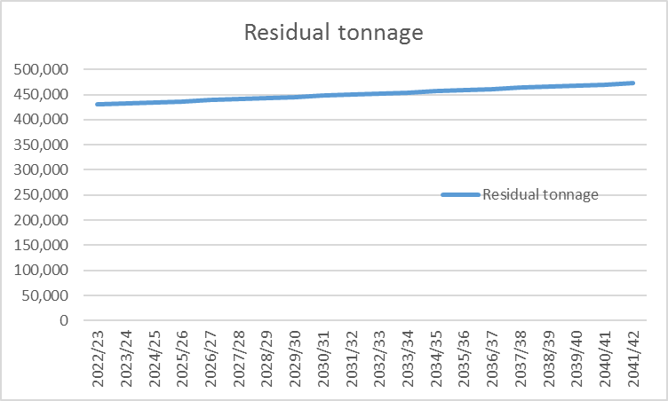

Overall expenditure – This equates to the total levies charged to boroughs and the chart below has been split to show the PAYT and FCL as well as the total. The chart illustrates the growth in overall expenditure and levies over time.

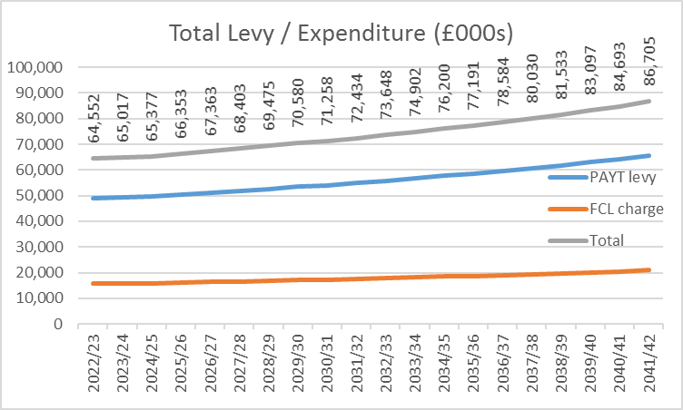

This chart above illustrates an average annual growth of 1.6% over the long-term which is significantly lower than the 2.5% underlying long term growth assumptions in the plan, principally inflation RPIX (2.0%) and annual growth in tonnages (0.5%) to reflect population rises.

This growth is contained as a result of the way the PPP contract is structured. This is because the first 235,000 tonnes is essentially protected from 90% of the effect of inflation. This significantly dampens the effect of inflation on residual waste costs over the whole life of the contract.

The dampened growth in costs and levies is further illustrated in the medium term in the chart below.
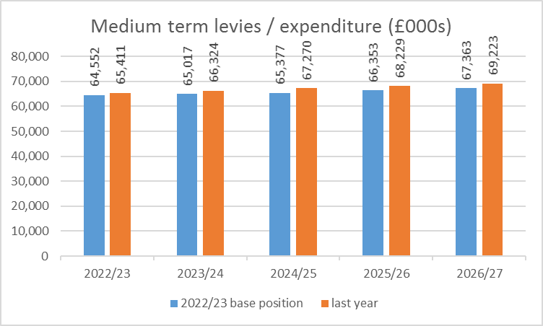

The table above shows an average growth in levies of 1.1% per year over the next 5 years. Boroughs may want to consider using this as an estimate of the increase in the WLWA levies within their medium term financial plans.

It also shows how the current medium term plan compares to the plan reported last year and this shows a consistent picture.

Debt / long-term liabilities and cash – The following chart illustrates the movement in the debt / long-term liabilities as they are paid / settled. The repayments commence at a low level and progress at increasingly larger sums, resulting in the debt/long term liability curve. The effect of the financing is reflected in the cash balances which build up in early years and fall in later years.

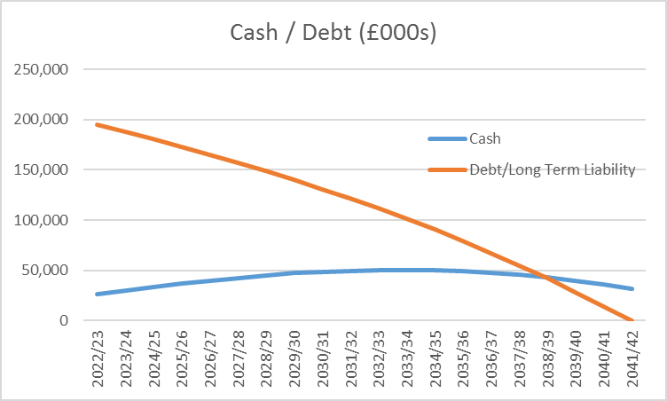

At the end of the plan, the Authority will be debt free.
Sensitivity Analysis
The two tables below illustrate that the impact of the change in residual waste volumes is the key driver of costs/levies with changes in inflation having a much smaller impact. This is because the effect of inflation is considerably dampened by the long term PPP contract.
Residual tonnages.
Residual waste growth assumption | Average rise in costs / levies over 5 years
-5% | -3.9%
-2% | -1.2%
-1.5% | -0.8%
-1% | -0.3%
-0.5% | 0.2%
0% | 0.6%
0.5% base | 1.1%
1% | 1.5%
1.5% | 2.0%
2% | 2.5%
5% | 5.2%
Similarly for residual contract inflation (RPIX).
Residual contract inflation RPIX | Average rise in costs / levies over 5 years
1% | 0.7%
2% base | 1.1%
3% | 1.4%
4% | 1.8%
5% | 2.2%
6% | 2.6%
The resource and waste strategy’s impacts are likely to be far reaching and long term. For the Authority the two key elements that will have a direct financial impact are the Deposit Return Scheme (DRS) and Extended Producer Responsibility (EPR).
Consumers will be incentivised to recycle DRS materials directly (e.g. drinks containers such as bottles and cans) so this is likely to reduce the volume of residual waste.
For EPR (packaging material e.g. card, plastics etc), Authorities will receive funding for their processing costs. This includes EPR waste in the residual waste stream.
The recent waste composition analysis provided a snapshot of the contents of the residual waste collection stream. It showed that 3% of the residual waste were materials that would be covered by the DRS and 20% by EPR. Changes to the residual waste composition for these materials will be the main factors.
Therefore the scenarios below show how the long term financial picture could improve if these government interventions are successful and waste is extracted from the residual waste stream.

DRS Scenarios | Average rise in costs / levies over 5 years
Base case, no DRS stripped out | 1.1%
1% stripped out | 0.9%
2% stripped out | 0.8%
All 3% of DRS material stripped out | 0.7%

EPR Scenarios | Average rise in costs / levies over 5 years
Base case, nothing funded by EPR | 1.1%
5% funded | 0.3%
10% funded | -0.5%
15% funded | -1.3%
All 20% of EPR materials funded | -2.0%
The above tables show that given the volume of EPR materials within the residual waste stream, this could have the biggest direct financial impact.
Whilst the RWS is reasonably clear about the type of key high level financial drivers for DRS and EPR, which improves the likelihood of some success, the scale of the financial drivers is less clear i.e. the amount consumers will pay as a deposit in DRS and the level of funding for EPR.
Also it is far less clear about financial drivers for food waste. However, the recent waste composition analysis identified 32% of the collected residual waste stream as food waste. On the basis of this high proportion it is important to also consider food waste sensitivities.
Food Scenarios | Average rise in costs / levies over 5 years
Base case, no food stripped out | 1.1%
5% stripped out | 0.4%
10% stripped out | -0.3%
15% of the 32% food moved to food stream | -1.0%
This shows that stripping out food waste from the residual waste stream and processing it through the food waste stream will deliver a reduction in costs and levies and importantly in the carbon impact.

Appendix 2



